Should you get pre-approved for a mortgage? Ten things to know…. 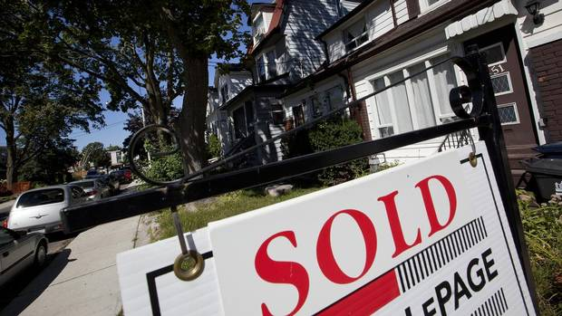
Robert McLister Special to The Globe and Mail Published Monday, Apr. 21 2014
Putting your full faith in a mortgage pre-approval is like betting on a heavy favorite in a horse race. You’ll probably win but there’s room for major disappointment.
Sure, pre-approvals have benefits.
- The best ones accurately measure your qualifications and how much house you can afford.
- Their 90- to 120-day rate guarantees protect you if rates rocket up while you’re home hunting.
- They make you seem more serious to sellers and real estate agents. (In competitive bidding situations, they’re almost mandatory.)
- They’re free and there’s no obligation to use the lender that pre-approved you.
But here’s the problem: pre-approvals are not full approvals. So if you’re going to rely on one, you need to understand their limitations.
Here are 10 pre-approval facts every mortgage shopper should know:
1. Pre-approvals aren’t created equal.
Many lenders don’t review your qualifications when issuing a pre-approval. They provide only a rate guarantee, subject to later approval. (Mortgage advisers should always disclose this.)
“I would caution consumers when a lender only holds a rate, versus asking for documents and confirming qualification,” says Rob Regan-Pollock, a mortgage broker with Invis. “It’s heartbreaking to be told by a lender they cannot qualify after being told they were ‘pre-approved’.”
2. Advice goes only so far.
Mortgage advisers can “pre-qualify” you to confirm that you meet general guidelines, but only a lender’s underwriter can confirm that your income, down payment, purchase agreement, property information, credit and debt ratios meet their full approval
Unless you have a 20 per cent down payment from your own resources, rock-solid employment, provable income, pristine credit, and low debt, then pick a lender that reviews your application and preferably your documentation before granting its pre-approval.
3. Appraisals are the missing link.
Appraisals aren’t done at the pre-approval stage. But they’re mandatory for getting a mortgage. The issue, of course, is that you can’t get an appraisal on a home you haven’t found yet. And that’s the big risk with pre-approvals. If the lender's or mortgage insurer's valuation appraisal reveals that you overpaid, or the property has defects, it can render your pre-approval worthless. That’s why you’re always wise to insert financing conditions in your purchase offer (or at least appraisal conditions) or get an appraisal before you make an offer.
Adding a financing condition is especially important if you’re putting down less than 20 per cent, which typically requires an insured mortgage. That’s because default insurers like CMHC don’t even look at pre-approvals. They can decline you or your property for any number of reasons, leaving those without financing conditions at risk of not closing, losing their deposit and being sued.
4. Don’t over-rely on appraisers.
Even if you get an appraisal before making your offer, “you can’t rely on appraisers to identify every problem with a property,” says Jason Upton, president of Aedis Appraisals. That’s especially true for condos where most appraisers (due to cost and time constraints) won’t review condo board minutes, condo finances and engineering reports. That’s where risks like special levies, reserve deficiencies, legal problems or structural issues can turn up, all of which can kill a lender’s interest and make a pre-approval worthless.
5. Your actions after pre-approval matter.
Beware that missing payments, adding debt, changing jobs, moving around your down payment money or co-signing for someone, among other things, can void your pre-approval.
6. Pre-approvals don’t come with the best rates.
Statistically, only around one in six pre-approved homeowners actually take the mortgage they got pre-approved for. But the lender still has costs (like rate hedging and application processing costs) for the five in six pre-approved mortgages that don’t close.
Given this expense, pre-approvals don’t typically come with the best pricing. They’re often 0.10 to 0.15 percentage points above market rates – which is peanuts compared to your costs if rates soar and you’re not pre-approved.
That said, the best mortgage rates are often for 30- or 45-day closings. Check rates 30 days before closing. If they’re more than 0.10 percentage points below your pre-approval rate, ask your lender to match them. If they won’t, consider re-applying elsewhere. But avoid trading a flexible mortgage for a restrictive one that’s only marginally cheaper. Homeowners routinely underestimate their need for refinancing flexibility later.
7. Sometimes waiting pays.
If you’re very well qualified, a mortgage broker can sometimes time the submission of your pre-approval to get you better rates. “If rates are flat or trending down, the discussion with the client becomes one of monitoring the market and not actually submitting the file until they are within the window of [rate] specials,” Mr. Regan-Pollock says.
8. Reset if appropriate.
If rates have stayed low and you’re still actively home hunting, reset your pre-approval every 45 to 75 days. This extends your rate hold, protecting you if rates jump before you close. If your lender restricts rate resets, you might need to look elsewhere.
9. Get a second pre-approval, if needed.
Lenders don’t issue more than one pre-approval at a time. So if 45 to 60 days have elapsed, rates have jumped, and you need more time to find a home, consider getting a second pre-approval elsewhere. On the other hand, if you know you won’t close within your original pre-approval’s time frame, save time and try to reset the rate hold period with the existing lender.
10. Features matter.
Choose the pre-approval with the longest rate hold (e.g., 120 days), the deepest discount rate, full underwriting and the best mortgage features (i.e., good prepayments, a fair penalty, good port and refinance policies, etc.). Only a minority of lenders meet this criteria.
Call me for your pre-approval. You still need to have it before you start your shopping.
As it was said before, pre-approval doesn’t mean always approval, but mortgage brokers usually see if deal will go through.
Stella Zisin
DLC Lender Direct
Bus: 780-455-4181
Cell: 780-707-8485

