My credit score is 788: What does it mean?
January 21, 2013 By Robb Engen
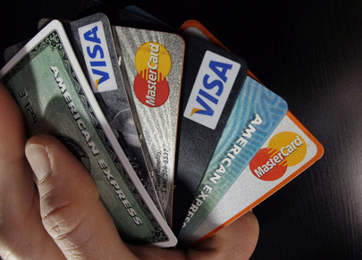
A good credit score is important if you plan to borrow money because it means you’ll qualify for lower interest rates on loans and have access to a variety of credit offers.
Your credit score indicates the risk you represent for lenders when compared to other consumers. Higher scores are viewed more favourably. The two credit-reporting agencies, Equifax and TransUnion, use a credit scoring scale from 300 to 900.
I've sent away for my free credit report a couple of times to check for errors, but that report doesn't include your score. I was curious and so last week I went to the Equifax website and paid $23.95 for my credit report and credit score online.
My credit score was 788, which isn’t perfect, but most lenders would consider it pretty good.
Credit Score | 300 to 559 | 560 to 659 | 660 to 724 | 725 to 759 | 760+
Quality | Poor | Fair | Good | Very good | Excellent
% of population | 4% | 10% | 15% | 14% | 57%
Your credit score is derived from a number of factors including:
- Payment history – carrying a balance on your credit card, or missing a payment
- Any collection or bankruptcy recorded against you
- Outstanding debts – the limit on your credit card (is your balance close to your limit?)
- Account history – how long have you had credit?
- Number of recent inquiries made about your credit report
- Type of credit you’re using – a mix of credit cards and loans
The most important factors are your payment history, whether you’ve ever declared bankruptcy, and the amount of your outstanding credit balances.
Here are six easy steps to improve your credit score:
Pay your bills on time: Utility bill payments aren’t recorded in your credit report, but some cell phone companies will report late payments to the credit-reporting agencies, which may impact your score.
Pay your bills in full: If you’re not able to do this, make sure to pay the required minimum amount shown on your monthly statement.
Stay below your credit limit: The higher your balance, the more impact it has on your credit score. Keep your balance under 50 per cent of your available limit at any time.
Keep credit applications to a minimum: If too many lenders ask about your credit in a short period of time, it can have a negative effect on your score.
Keep a credit history: You may have a low credit score because you don’t have a record of borrowing money and paying it back.
Fix errors in your report: Ask for a free copy of your credit report once a year and check it for accuracy. If you notice any errors, get them fixed as soon as possible.
You shouldn't obsess over your credit score – it only matters if you plan on borrowing. So if you've borrowed responsibly in the past you shouldn't have any trouble getting credit in the future.

